DEVELOPING YOURSELF BY DEVELOPING OTHERS

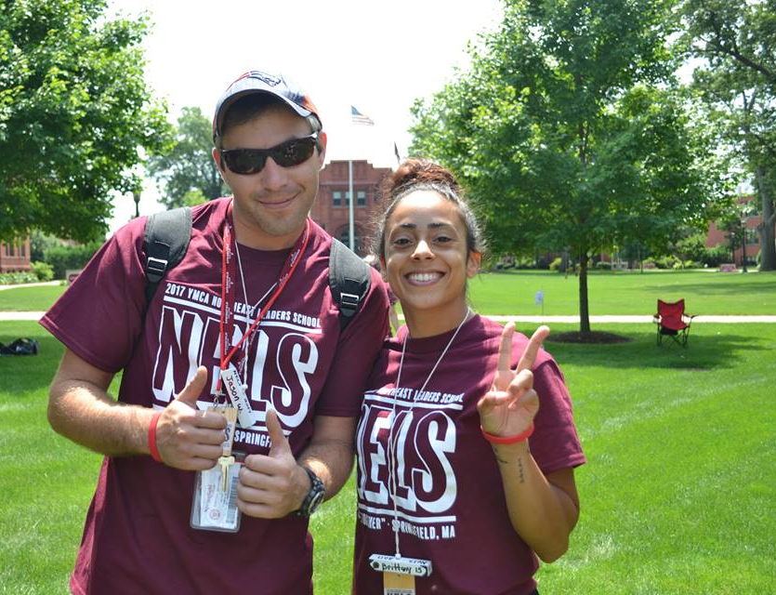

YMCA NORTHEAST LEADERS SCHOOL STAFF APPLICATION
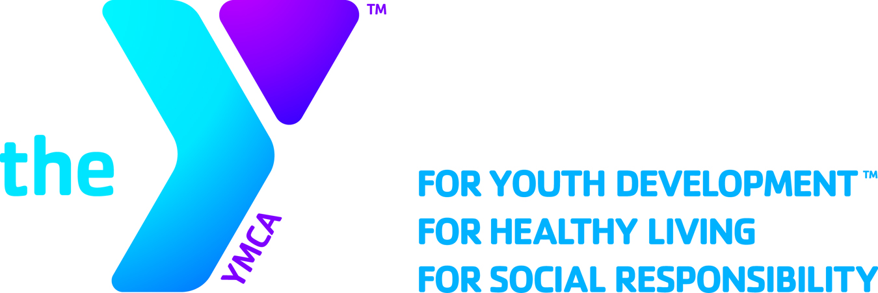
YMCA NORTHEAST
LEADERS SCHOOL

ABOUT LEADERS SCHOOL
The YMCA Northeast Leaders School is the premier teen leadership conference in the Northeast that has been training teens and staff to become servant leaders in their YMCA and their communities since 1974. Located at Springfield College in Springfield Massachusetts this program serves teens from Leaders Club programs in the states of RI, MA, CT, NY, NH and VT. Leaders School offers leadership development in three core program areas, elective programming and a values based curriculum that help teens clarify their beliefs and ideas. Staffed by YMCA professionals and volunteers, Leaders School provides teens and staff alike a unique leadership training and development experience.

WHO CAN APPLY? IS THERE A COST?
- YMCA affiliated staff or volunteers can apply. Applicants can be part time or full time, exempt or non-exempt, staff or volunteers.
- Applicants must be able to fully attend staff training weekend in May and the entire School Program in July. See application for dates.
- Applicants should also be comfortable working directly with a diverse group of teens ages 13-18 and adult staff of various backgrounds and experience levels.
- Previous experience with the YMCA Teen Leaders Club program is preferred but not required.
- There is ZERO cost to be on staff. It only costs your time and expertise! Meals, housing, training, etc. are all provided without cost to you or your YMCA.

WHAT IS EXPECTED OF STAFF?
Staff create and deliver cutting edge programs to teens in one of our three core program areas; Physical Education, Aquatics, and Special Interest. Staff also create additional activities outside their departments and facilitate small group values sessions with teens. Most importantly staff are expected to be strong role models and develop positive relationships with teen participants and other staff to maximize impact.

BENEFITS OF BEING ON LEADERS SCHOOL STAFF
Skill Development
Including but not limited to public speaking, large and small group facilitation, program development, time management, organizational skills, listening/coaching, and conflict resolution. Staff often develop additional functional expertise in various program areas such as sports, arts, aquatics, and others.

YMCA Competency Development
YMCA Competencies our staff cite as being developed include Values, Community, Communication, Developing Others, Inclusion, Relationships, Quality Results, Project Management and Emotional Maturity.

Leadership Opportunities
Many leadership opportunities exist for staff to further develop their leadership skills. These include being a lead staff for activities, mentoring new staff and leadership roles on the school’s management team.

Career Development & Coaching
Network with other professionals to learn and advance your career. The School also has a dedicated staff development expert to provide competency growth, coaching and career guidance.

A LETTER FROM THE
SCHOOL’S DIRECTOR

Dear YMCA Colleague,

Thank you for your interest in the YMCA Northeast Leaders School. Our School has a rich history of developing teens and staff through powerful programs and experiences. The Northeast Leaders School, held this year at Springfield College, aims to meet the needs of the individual teen by providing them with skill development and valuable personal and group experiences. The teens participate in a structured program that includes leadership development and teaching skills in three program areas; Aquatics, Physical Education and Special Interests. The teens also learn to clarify their values through character development and values education as well as participate in elective programs that help broaden their interests.

As valuable as this experience is for the teens it also has an equal impact on the staff who attend. Leaders School is a premier training opportunity for all YMCA staff. Leaders School staff will practice and perfect their facilitation skills and develop their group work skills through the creation of cutting edge curriculum. Being on staff also provides you with an invaluable network of YMCA professional staff and volunteers that will give you ongoing support. Through this experience you will also get to see the Y’s mission in action and will find yourself reinvigorated for your work back home.

Leaders School is an amazing experience for everyone involved. Our mandatory Staff Training Weekend will take place May 18th -May 20th at Springfield College in Springfield MA. Our pre-School training starts on July 28th (we ask that you arrive on Friday July 27th between 5:00-8:00pm) and Leaders School begins on Sunday, July 29th and goes until mid-afternoon August 3rd. There is an option for staff to stay overnight August 3rd for a staff celebration evening.

If you are available on those dates and interested on joining our staff team, please fill out the attached staff application and send it back to me by March 1st. The Leaders School Management Team will review your application and will contact you with our decision by the end of March/early April. If you have question regarding Leaders School, please feel free to contact me at the information below. Thank you very much!

Sincerely,

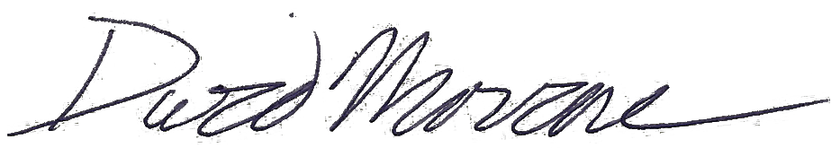

Dave Morrone
YMCA Northeast Leaders School Director
Training Manager – YMCA of Greater Boston
dmorrone@ymcaboston.org
617-913-5721

LEADERS SCHOOL
STAFF APPLICATION FORM

Important Dates – SAVE THESE! Please return by March 1st via mail or email to
Staff Training Weekend – May 18th-20th Dave Morrone, dmorrone@ymcaboston.org
Pre-School Training – July 27th-29th YMCA of Greater Boston
Leaders School Program – July 29th – August 3rd 316 Huntington Ave, Boston MA 02115
BASE INFORMATION

Name (please include any preferred names you go by) |  | Gender Identity | Date of Birth
Email Address – one you check frequently! |  | Daytime Phone & Cell Phone
 |  | Day: | Cell:
# of Years as a Leaders Club Advisor |  | # of Leaders Club Rallies Attended (as staff/adult)
 | Are you currently a club advisor? Yes No
# of Years on Leaders School Staff |  | Were You in Leaders as a Teen? Year Graduated?
 |  | Yes No | Year you graduated  if yes:

YMCA INFORMATION & PREVIOUS LEADERS CLUB EXPERINECE

YMCA Branch |  | YMCA Association
Position / Title |  | Mailing Address
Current Status |  | # of Years in YMCA Work
PT FT Hourly FT Exempt Volunteer
Brief Summary of your YMCA Job Duties & Experiences in Youth/Teen Work
Supervisor Name & Title |  | Supervisor Contact Info
 |  | Phone: | Email:
Have you Completed Child Abuse Prevention Training? |  | Were You/Are You a Certified Lifeguard?
Yes No | Date Complete if yes: | Yes (previously) Yes (currently) No
LEADERS SCHOOL
STAFF APPLICATION FORM

PROGRAM DEPARTMENT & SKILLS

Program Area Choice - Please rank your 1st choice, 2nd choice and 3rd choice for department preference
 | Click to Choose | Aquatics - Pool & aquatic programming, swimming/swim lessons, lifeguarding, boating, safety
 | Click to Choose | Physical Education - Sports & recreation, dance, gymnastics, fitness, coaching
 | Click to Choose | Special Interest (SI) - Arts & humanities, crafts, performing arts, childcare/camp, outdoor education, sciences.
AQUATIC CERTIFICATIONS – Please list any aquatic certifications you hold
Please also send copies of those certifications, front and back
PHYSICAL EDUCATION CERTIFICATIONS – Please list any health & wellbeing, fitness, outdoor adventure, or sports related certifications you hold. Please also send copies of those certifications, front and back
ADDITIONAL EXPERIENCE – Brag a little! Please list any additional talents & expertise you have that you could use to create a class/program with. Please attach any related certifications, front and back, if applicable.

YMCA & SAFETY CERTIFICATIONS
Please list any other certifications that you hold (Teen Leadership, Youth Sports, Adventure Guides, Substance Abuse Prevention, Child Care, Day Camp, CPR, First Aid, EMT, etc.). YMCA P&P and/or Modules you have completed; include any certification and/or expiration dates as pertinent. You can also attach your YMCA transcript.

Certification Name | Date Achieved | Expiration (if applicable)

LEADERS SCHOOL
STAFF APPLICATION FORM

ADDITIONAL INFORMATION

What experience do you have involving small group discussions on values, character, or leadership?
Age group comfort level - Circle all that apply | Teen Group Preference – Circle all that apply
13–14 year olds 15–16 year olds 17–18 year olds | 1st Years 2nd Years Vets/GV’s  (1st time attending) (2nd time attending) (3+ years/graduates)
What do you expect / hope to gain from your Leaders School Experience? What goals do you have?
How would the Leaders School program benefit from having you on staff?

YMCA COMPETENCIES
The YMCA has an extensive competency development model for staff. Please tell us your strengths and areas of development in these competencies.

In the list below, CHECK the TOP 3-6 competencies you feel strongest in, and CIRCLE the TOP 3-6 competencies you’d like further development with. You can both check and circle a competency if you feel strong in it but want further development.

For information on how competencies are defined please click here. School staff are typically Leaders or Team Leaders.

MISSION ADVANCEMENT | COLLABORATION | OPERATIONAL EFFECTIVENESS | PERSONAL GROWTH
_______ Values  _______ Community  _______ Volunteerism  _______ Philanthropy | _______ Inclusion  _______ Relationships  _______ Influence  _______ Communication  _______ Developing Others | _______ Decision Making  _______ Innovation  _______ Project Management  _______ Finance  _______ Quality Results | _______ Self-Development  _______ Change Capacity  _______ Emotional Maturity  _______ Functional Expertise

LEADERS SCHOOL
STAFF APPLICATION FORM

Staff Commitment
Please accept this application as a definite commitment towards my interest in attending the 2018 YMCA Northeast Leaders School.

______________________________________________________________________________________________________________________________
Signature Date

Please check that you have enclosed the following
( )-Completed Staff Application with copies of relevant certifications (front & back)
( )-Social networking policy sign off page

Please check one: ( )-I am a current YMCA staff/volunteer (if yes have your Exec. complete the below)
( )-I am not current affiliated with a YMCA

Executive Director’s Agreement

________________________________________________________________________ (applicant) has the commitment of the
________________________________________________________________________ YMCA to apply and attend the 2018 YMCA Northeast Leaders School if accepted as a member of the staff.

YMCA of ___________________________________________________________________ (your association) verifies that the above staff/volunteer has completed the following:

Reference Check Date ___________
Criminal Background Check Date ___________

__________________________________________________________________________________________________________________________________
Executive Director Name & Signature Date

Applications are due March 1st 2018
Please return application and any certification copies by mail or email (email scan preferred) to:
YMCA of Greater Boston
Attn: Dave Morrone – HR Department
316 Huntington Ave
Boston, MA 02115
dmorrone@ymcaboston.org

Mandatory Attendance Dates for Northeast Leaders School 2018
Staff Training Weekend - May 18th – May 20th – Arrival time on the 18th is 12pm
Pre-school training - July 27th – July 29th – Arrival time is between 5 - 8pm on the 27th
Leaders School Program - July 29th – August 3rd

If you have any questions about this application or Leaders School in general, please contact Dave Morrone - Leaders School Director at (617) 913-5721 or dmorrone@ymcaboston.org
YMCA Northeast Leaders School
Social Networking Policy

Opening Statement:

Families entrust their teens to the YMCA Northeast Leaders School care for Leaders school. Our promise to these families is that we will provide a safe environment in which all participants are treated in a caring, honest, respectful and responsible way.

NELS believes in online communities and acknowledges them as a valuable component of shared media. This policy has been developed for management team, staff and volunteers who maintain personal sites (i.e. Instagram, Facebook, Twitter, Blogs, etc.)

YMCA Northeast Leaders School Code of Conduct for Social Networking Sites

It is every staff member’s responsibility to deliver on the Y’s promise and mission and to project and further the mission. This includes all dealings with the community; inside and outside the NELS community. This policy is in effect at all times, not just during school and training times. It is the responsibility of any NELS staff to avoid any inappropriate speech or behavior in the presence of our community members at all times.

Staff is responsible for the content of all text, audio or images that are placed or sent over the Internet. Fraudulent, abusive, profane, harassing or obscene messages are expressly prohibited. No messages with personal, derogatory or inflammatory remarks about an individual’s or group’s race, religion, national origin, physical attributes or sexual orientation may be transmitted. Information transmitted should not violate or infringe upon the rights of others. You are hereby advised to be mindful that the information you post on the internet, text or email will likely be seen by members of the NELS community and may reflect poorly on your character. As an organization that holds personal character in the highest regard, NELS is obligated to take actions to preserve its core values. NELS may ask a staff member not to serve on NELS staff for publishing material that is contrary to the NELS’s values and mission or are detrimental to its community.

NELS does not intend to interfere with any Staff’s private life, but publicly observable communications, actions or words are not private. All NELS staff must use good judgment and discretion. If you want your use of technology to be private, do not allow it to be seen in the electronic public forum.

Report Unsanctioned Contact

In the child abuse prevention policy and code of conduct that all staff of NELS have signed and have agreed to have no contact with NELS program participations outside of the professional settings of the program

Anyone applying to be on staff for NELS will have a media search completed by a member of the management team of the school. No application can be accepted until it is certain that they do not have social networking ability with teens that are currently able to attend the NELS program.

If you choose to post a personal website, or to participate in social media, (i.e. FaceBook) chat rooms or blogs, the following guidelines must be followed:

Social Networking Code of Conduct

1. The YMCA Code of Conduct requires that staff do not initiate outside contact with NELS program participants. Under no circumstances should a staff encourage or accept a friend request to or from his or her personal website or blog to a teen member or program participant of NELS. After a 6 month time period of the program participant no longer being eligible for the program may a staff member give access to their personal websites or social media pages.

2. NELS staff must uphold the YMCA’s value of respect for the individual and avoid making defamatory statements about NELS, NELS staff , participants, host sites, families or others including competitors.

3. NELS Staff may not share any personal email address or instant message name or nickname with youth.

4. Your personal website should be marked “private,” so only the people that you have invited may access your page. As an NELS staff, you are prohibited from inviting YMCA Leaders to access your website. Befriending with limited profile access is not allowed.

5. Any personal website, blog or Facebook interaction should not contain commentary that violates your local YMCA’s policies on harassment or discrimination.

6. You are solely responsible for any legal liability arising from or relating to the content from your personal website and/or blog.

7. If you have a professional Facebook page, it must meet the same guidelines set above for your personal social media account

8. If you have a YMCA approved social media page for your Leaders Club, you may invite teens to that page. This page must be monitored by your home YMCA and approved by your Executive Director.

YMCA Northeast Leaders School Social Networking Staff Agreement

Name (please print) ____________________________________

I acknowledge that as a staff, I am a representative of the YMCA Northeast Leaders School and that program participant’s and other staff members may associate me and my actions with NELS. I recognize that my actions may positively or negatively impact NELS, thus I hereby agree to be bound by the general NELS rules as well as those governing online communications both during the period of the school and after.

Please check the following statements as you agree to them and agree to follow the YMCA NELS Social Networking Policy.

( ) I will not send, share or post e-mail, blogs, images, videos or content that is cruel, demeaning, disrespectful or intentionally hurtful to a member of the NELS community. I will respect the boundary between program participants and staff members particularly when it comes to my online communications.

( ) I agree that such actions are not in line with the values of NELS or the teachings of YMCA core values of Caring, Honesty, Respect, and Responsibility. I agree that the harm caused by such actions may have a negative impact on my reputation and may injure the self-esteem of Leaders of the NELS community and therefore may result in no-longer being asked to serve on the NELS staff.

( ) I agree to set my social networking sites to “Private” so that only individuals that I approve may see the content of my site.

( ) I agree to not to accept program participants as “Friends” so they have unlimited access to my site.

( ) I agree to report any and all inappropriate interaction of the policy to the management team of NELS.

( ) I agree to be bound by the NELS Code of Conduct and rules governing online communications.

( ) I agree to remove any current leaders as friends from social networking using the following statement.

“Dear Friend: Thank you for our time as friends on this social networking page, I have enjoyed our interaction and getting to know you. I have to adjust my settings and because you are eligible to take part in a program that I volunteer/work for I can no longer use social media as a form of communication between the two of us. Please know this is a professional based decision and many organizations are moving in this direction.”

Signed: ________________________________________ Date: ___________

